Christ Episcopal Church
A Parish of the Anglican Communion
May 18, 2025, 10:00AM
________________________________________________________________________

Empowered by Jesus to love, serve, and lead.
(Christ Church’s Mission Statement)

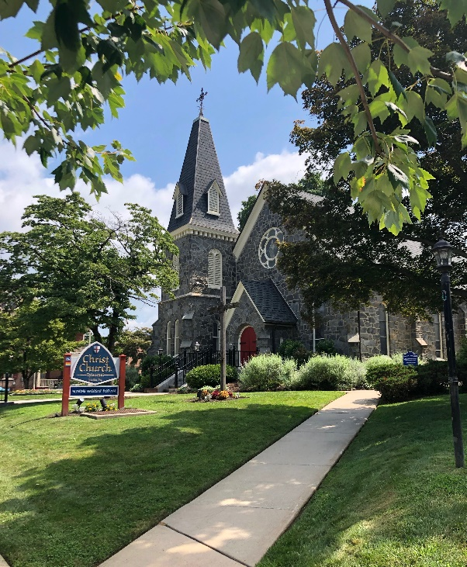

The Fifth Sunday of Easter
Holy Eucharist Rite II

Welcome! Whether you are visiting for the first time or are a lifelong member, we are glad you are here. Whatever your religious background and wherever you are on your faith journey, we hope you encounter the Sacred here.
You’ll notice that in our worship services not all people participate in exactly the same ways. Part of what makes The Episcopal Church special is that people with diverse beliefs and practices worship together here. We invite you to participate in the service as you feel comfortable. You are free to sit, stand or kneel; cry and laugh; doubt and question; hold hands with your partner; sit silently; or sing off key. Children are a blessing, not a bother, so don’t be worried if they wiggle.
Most of the material you need is in this bulletin; as well as The Hymnal 1982, the songbook Lift Every Voice and Sing (LEVAS) and the Book of Common Prayer (has a cross on the front). There are Bibles in the pews in various translations, feel free to leaf through, or even take one, if you’d like.
The Holy Eucharist is Christ’s eternal banquet. In the Episcopal Church it is our tradition to welcome everyone to receive communion. This is God’s table, not our table; and God welcomes everyone to share in the Body of Christ.
Following the service, please join us for refreshments in St. Joseph’s Hall. There are often presentations of varied topics of interest in the Adult Forum.
If you have questions about our church, please speak with a clergyperson, one of the ushers, or a greeter after the service or contact the church office, 610-566-7525 or rita@christchurchmedia.org. To join our emailing list, please fill out the tan visitor card in your pew and give it to an usher or put it in the collection plate.
God loves and accepts you, just as you are, and we do too. Welcome!
The Rt. Rev. Daniel G.P. Gutierrez - Bishop
The Rev. Fr. Ernest Galaz – Rector
The Rev. Dcn. Joseph German - Deacon
Mr. Kurt Brunner – Senior Warden

The Fifth Sunday of Easter
Celebrant: The Rev. Ernest Galaz, Rector
Deacon: The Rev. Joseph German
Organist: Mr. Joel Lenderman

Please bring all conversations to an end and use this time for reflection, meditation, preparation and prayer.

Processional Hymn 296 “We know that Christ is raised”
We know that Christ is raised and dies no more.
Embraced by death he broke its fearful hold;
And our despair he turned to blazing joy.
Alleluia! Alleluia! Amen.

We share by water in his saving death.
Reborn we share with him an Easter life
As living members of a living Christ.
Alleluia! Alleluia! Amen.

The Father’s splendor clothes the Son with life,
The Spirit power shakes the Church of God.
Baptized we live with God the Three in One.
Alleluia! Alleluia! Amen.

A new creation comes to life and grows
As Christ’s new body takes on flesh and blood.
The universe restored and whole will sing:
Alleluia! Alleluia! Amen.

Celebrant Alleluia. Christ is risen.
People The Lord is risen indeed. Alleluia.
Celebrant Almighty God, to you all hearts are open, all desires known, and from you no secrets are hid: Cleanse the thoughts of our hearts by the inspiration of your holy Spirit, that we may perfectly love you, and worthily magnify your holy Name; through Christ our Lord.
People Amen.

Gloria – Lau
Glory to God in the highest, and peace to his people on earth.
Lord God, heavenly King, Almighty God and Father.
We worship you. We adore you.
Glory to God, Glory to God, Glory to God in the highest.
The Collect
Celebrant The Lord be with you.
People And also with you.
Celebrant Let us pray… Almighty God, whom truly to know is everlasting life: Grant us so perfectly to know your Son Jesus Christ to be the way, the truth, and the life, that we may steadfastly follow his steps in the way that leads to eternal life; through Jesus Christ your Son our Lord, who lives and reigns with you, in the unity of the Holy Spirit, one God, for ever and ever.
People Amen.

The First Lesson Acts 11:1-18
Now the apostles and the believers who were in Judea heard that the Gentiles had also accepted the word of God. So when Peter went up to Jerusalem, the circumcised believers criticized him, saying, "Why did you go to uncircumcised men and eat with them?" Then Peter began to explain it to them, step by step, saying, "I was in the city of Joppa praying, and in a trance I saw a vision. There was something like a large sheet coming down from heaven, being lowered by its four corners; and it came close to me. As I looked at it closely I saw four-footed animals, beasts of prey, reptiles, and birds of the air. I also heard a voice saying to me, `Get up, Peter; kill and eat.' But I replied, `By no means, Lord; for nothing profane or unclean has ever entered my mouth.' But a second time the voice answered from heaven, `What God has made clean, you must not call profane.' This happened three times; then everything was pulled up again to heaven. At that very moment three men, sent to me from Caesarea, arrived at the house where we were. The Spirit told me to go with them and not to make a distinction between them and us. These six brothers also accompanied me, and we entered the man's house. He told us how he had seen the angel standing in his house and saying, `Send to Joppa and bring Simon, who is called Peter; he will give you a message by which you and your entire household will be saved.' And as I began to speak, the Holy Spirit fell upon them just as it had upon us at the beginning. And I remembered the word of the Lord, how he had said, `John baptized with water, but you will be baptized with the Holy Spirit.' If then God gave them the same gift that he gave us when we believed in the Lord Jesus Christ, who was I that I could hinder God?" When they heard this, they were silenced. And they praised God, saying, "Then God has given even to the Gentiles the repentance that leads to life."

Reader The Word of the Lord.
People Thanks be to God.

Psalm 148
1 Hallelujah!
Praise the Lord from the heavens; *
praise him in the heights.
2 Praise him, all you angels of his; *
praise him, all his host.
3 Praise him, sun and moon; *
praise him, all you shining stars.
4 Praise him, heaven of heavens, *
and you waters above the heavens.
5 Let them praise the Name of the Lord; *
for he commanded, and they were created.
6 He made them stand fast for ever and ever; *
he gave them a law which shall not pass away.
7 Praise the Lord from the earth, *
you sea-monsters and all deeps;
8 Fire and hail, snow and fog, *
tempestuous wind, doing his will;
9 Mountains and all hills, *
fruit trees and all cedars;
10 Wild beasts and all cattle, *
creeping things and winged birds;
11 Kings of the earth and all peoples, *
princes and all rulers of the world;
12 Young men and maidens, *
old and young together.
13 Let them praise the Name of the Lord, *
for his Name only is exalted,
his splendor is over earth and heaven.
14 He has raised up strength for his people
and praise for all his loyal servants, *
the children of Israel, a people who are near him.
Hallelujah!

The Epistle Revelation 21:1-6
I saw a new heaven and a new earth; for the first heaven and the first earth had passed away, and the sea was no more. And I saw the holy city, the new Jerusalem, coming down out of heaven from God, prepared as a bride adorned for her husband. And I heard a loud voice from the throne saying,
"See, the home of God is among mortals.
He will dwell with them as their God;
they will be his peoples,
and God himself will be with them;
he will wipe every tear from their eyes.
Death will be no more;
mourning and crying and pain will be no more,
for the first things have passed away."
And the one who was seated on the throne said, "See, I am making all things new." Also he said, "Write this, for these words are trustworthy and true." Then he said to me, "It is done! I am the Alpha and the Omega, the beginning and the end. To the thirsty I will give water as a gift from the spring of the water of life."
Reader The Word of the Lord.
People Thanks be to God.

Gradual Hymn 529 “In Christ there is no East or West”
In Christ there is no East or West,
in him no South or North,
but one great fellowship of love
throughout the whole wide earth.

Join hands, disciples of the faith,
what e’er your race may be!
Who serves my Father as his child
is surely kin to me.

In Christ now meet both East and West,
in him meet South and North,
all Christly souls are one in him,
throughout the whole wide earth.
The Gospel

Priest The Holy Gospel of our Lord Jesus Christ, according to John 13:31-35
People Glory to you, Lord Christ.

At the last supper, when Judas had gone out, Jesus said, "Now the Son of Man has been glorified, and God has been glorified in him. If God has been glorified in him, God will also glorify him in himself and will glorify him at once. Little children, I am with you only a little longer. You will look for me; and as I said to the Jews so now I say to you, 'Where I am going, you cannot come.' I give you a new commandment, that you love one another. Just as I have loved you, you also should love one another. By this everyone will know that you are my disciples, if you have love for one another."
Priest The Gospel of the Lord.
People Praise to you, Lord Christ.

The Sermon

The Nicene Creed
We believe in one God, the Father, the Almighty,
maker of heaven and earth, of all that is, seen and unseen.
We believe in one Lord, Jesus Christ, the only Son of God,
eternally begotten of the Father, God from God, Light from Light.
true God from true God, begotten, not made,
of one Being with the Father; through him all things were made.
For us and for our salvation he came down from heaven;
by the power of the Holy Spirit he became incarnate from the
Virgin Mary and was made man (truly human).
For our sake he was crucified under Pontius Pilate;
he suffered death and was buried.
On the third day he rose again in accordance with the Scriptures;
he ascended into heaven and is seated at the right hand of the Father.
He will come again in glory to judge the living and the dead,
And his kingdom will have no end.
We believe in the Holy Spirit, the Lord, the giver of life,
who proceeds from the Father (and the Son),
with the Father and the Son he is worshiped and glorified.
he has spoken through the prophets.
We believe in one holy catholic and apostolic Church.
We acknowledge one baptism for the forgiveness of sins.
We look for the resurrection of the dead, and the life of the world to come. Amen.
The Prayers of the People
Gathered together in the name and power of our risen Lord, through whom the glory of God is revealed, let us offer our prayers to Almighty God, saying: Lord, hear our prayer.

Leader: That heavenly peace may descend upon us and upon the whole world, we pray to you,
O Lord.
People: Lord, hear our prayer

Leader: That we may love one another as Christ has commanded us, we pray to you, O Lord.
People: Lord, hear our prayer.

Leader: That the church throughout the world and in this congregation may be united in peace, empowered by the Spirit, and faithful in its mission to all humankind, we pray to you, O Lord.
People: Lord, hear our prayer.

Leader: That the power of Christ’s victory over death may show itself among us, bringing freedom, joy, light, and life to those in need, we pray to you, O Lord.
People: Lord, hear our prayer.

Leader: Together with all others united to us in the communion of the risen Lord, for all that we need in this life and in your eternal dominion, we pray to you, O Lord.
People: Lord, hear our prayer.

The people add their petitions and thanksgiving aloud or silently.

The Celebrant concludes with a Collect
Grant, eternal God, that we who are made one with Jesus Christ in the power of his death and resurrection may show forth in our lives the love which proclaims us his disciples, that the world may believe in you and be saved, through Christ our Lord.
People Amen.

The Peace (All Stand)
Celebrant The peace of the Lord be always with you.
People And also with you.

Greetings and Announcements

Prayer for Birthdays
O God, our times are in your hand: Look with favor, we pray, on your servants as they begin another year. Grant that they may grow in wisdom and grace, and strengthen their trust in your goodness all the days of their lives; through Jesus Christ our Lord. Amen.

Prayer for Travelers
O God, our heavenly Father, whose glory fills the whole creation, and whose presence we find wherever we go: Preserve those who travel; surround them with your loving care; protect them from every danger; and bring them in safety to their journey’s end; through Jesus Christ our Lord. Amen.

Congregation is seated for the Offertory Anthem
Offertory Anthem “Come Sing Unto the Lord” -J. Martin

Doxology
Praise God, from whom all blessings flow; praise him, all creatures here below; praise him above, ye heavenly host: praise Father, Son, and Holy Ghost. Amen.

The Great Thanksgiving, (Eucharistic Prayer B)
Celebrant The Lord be with you.
People And also with you.
Celebrant Lift up your hearts.
People We lift them to the Lord.
Celebrant Let us give thanks to the Lord our God.
People It is right to give God thanks and praise.

It is right, and a good and joyful thing, always and every-where to give thanks to you, Father Almighty, Creator of heaven and earth. Therefore we praise you, joining our voices with Angels and Archangels and with all the company of heaven, who for ever sing this hymn to proclaim the glory of your Name:

Sanctus - Lau
Holy, Holy, Holy Lord, God of power and might.
Heaven and earth are full of your glory.
Hosanna in the highest.
Blessed is he who comes in the name of the Lord.
Hosanna in the highest, Hosanna in the highest.

The Celebrant continues
We give thanks to you, O God, for the goodness and love which you have made known to us in creation; in the calling of Israel to be your people; in your Word spoken through the prophets; and above all in the Word made flesh, Jesus, your Son. For in these last days you sent him to be incarnate from the Virgin Mary, to be the Savior and Redeemer of the world. In him, you have delivered us from evil, and made us worthy to stand before you. In him, you have brought us out of error into truth, out of sin into righteousness, out of death into life.

On the night before he died for us, our Lord Jesus Christ took bread; and when he had given thanks to you, he broke it, and gave it to his disciples, and said, “Take, eat: This is my Body, which is given for you. Do this for the remembrance of me.”

After supper he took the cup of wine; and when he had given thanks, he gave it to them, and said, “Drink this, all of you: This is my Blood of the new Covenant, which is shed for you and for many for the forgiveness of sins. Whenever you drink it, do this for the remembrance of me.”
Therefore, according to his command, O Father,

Celebrant and People
We remember his death,
We proclaim his resurrection,
We await his coming in glory.

The Celebrant continues
And we offer our sacrifice of praise and thanksgiving to you, O Lord of all; presenting to you, from your creation, this bread and this wine.

We pray you, gracious God, to send your Holy Spirit upon these gifts that they may be the Sacrament of the Body of Christ and his Blood of the new Covenant. Unite us to your Son in his sacrifice, that we may be acceptable through him, being sanctified by the Holy Spirit. In the fullness of time, put all things in subjection under your Christ, and bring us to that heavenly country where, with all your saints, we may enter the everlasting heritage of your sons and daughters; through Jesus Christ our Lord, the firstborn of all creation, the head of the Church, and the author of our salvation.

By him, and with him, and in him, in the unity of the Holy Spirit all honor and glory is yours, Almighty Father, now and for ever. Amen.

And now, as our Savior Christ has taught us, we are bold to say,

Our Father, who art in heaven, hallowed be thy Name, thy kingdom come, thy will be done, on earth as it is in heaven. Give us this day our daily bread. And forgive us our trespasses, as we forgive those who trespass against us. And lead us not into temptation, but deliver us from evil. For thine is the kingdom, and the power, and the glory, for ever and ever. Amen.

The Breaking of the Bread
Alleluia. Christ our Passover is sacrificed for us.
Therefore let us keep the feast. Alleluia.

Fraction Anthem “Whoever Comes to Me” A. Clarke
Whoever comes to me shall not hunger,
And whoever believes in me shall never thirst:
Send out your light and your truth
That they may lead to your holy hill;

The Gifts of God for the People of God. Take them in remembrance that Christ died for you, and feed on him in your hearts by faith, with thanksgiving. The Body of Christ for the Body of Christ. Be what you see. Receive what you are.

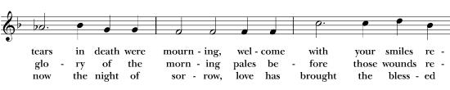
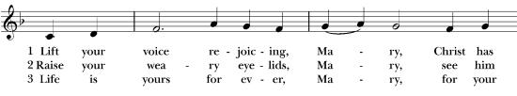
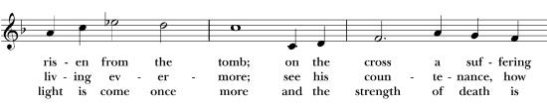
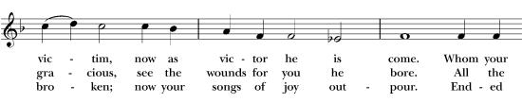
Communion Hymn 190 “Life your voice rejoicing”
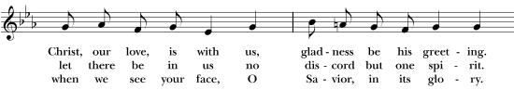
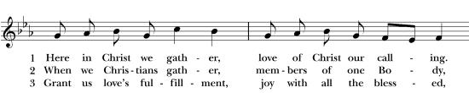
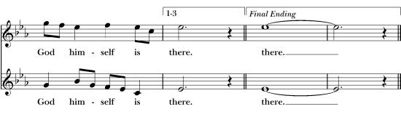
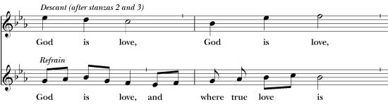
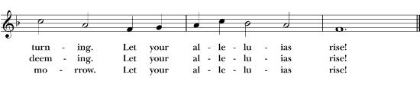
Hymn 576 “Here in Christ we Gather”
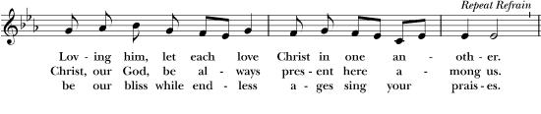
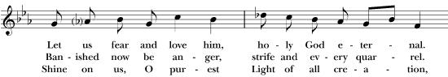
After Communion, the Celebrant says
Let us pray.

Celebrant and People
Almighty and everliving God, we thank you for feeding us with the spiritual food of the most precious Body and Blood of your Son our Savior Jesus Christ; and for assuring us in these holy mysteries that we are living members of the Body of your Son, and heirs of your eternal kingdom. And now, Father, send us out to do the work you have given us to do, to love and serve you as faithful witnesses of Christ our Lord. To him, to you, and to the Holy Spirit, be honor and glory, now and for ever. Amen.

The Blessing

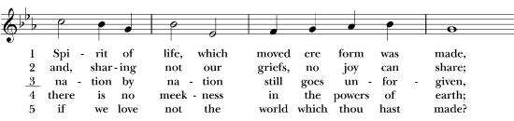
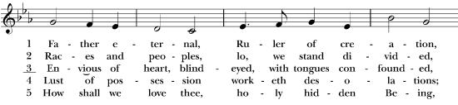
Recessional Hymn 573 “Father eternal, Ruler of creation”
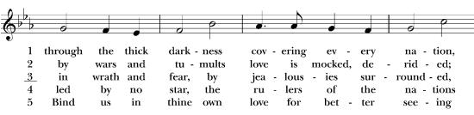
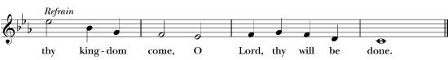
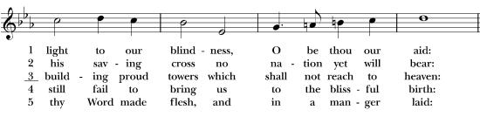

Dismissal
Deacon Let us bless the Lord, Alleluia, Alleluia.
People Thanks be to God, Alleluia, Alleluia.

The Altar Flowers are given to the Glory of God
by Nancy & Dennis Shea in loving memory of Dory.

INTERCESSORY PRAYER LIST – (friends, family and acquaintances of parishioners)
Pat, Barbara, Doug, Debbie, Kurt, Connor, Bruce, Bonnie, Cynthia, Robert, Mark, Linda, Greg, Cecelia, Chris, Rose, Tim, Dolores, Jean, Jeannine, Paula, John, Joanne, Bette, Beth, Emily, Wayne, Grace, Tom, Katie, Jerry, Fred

WE CELEBRATE THIS WEEK
BIRTHDAYS: Pat Rizzo, John Dyitt, Barbara Wooters, Brad Weber, Dillen Wible, Bobbi Morris, Mary Ann Klassen
ANNIVERSARIES: Kate & Rob Miller

SUNDAY WORSHIP SERVICE 8am Holy Eucharist Rite I and 10am Holy Eucharist Rite II, the 10am service is live-streamed.

WEDNESDAY PRAYER, BIBLE STUDY, and SERVICE Every Wednesday, all are invited to join in a spiritually uplifting morning. Intercessory Prayer at 10am; Bible Study at 11am in the Rector’s Office. Following Bible Study, the midday service is offered in the Chapel. All are welcome!

NURSERY CARE Nursery care is available today from 9:30am—12:30pm for infants to 3 years of age in the Acorn Classroom located on the lower level. De Anna Hickson, Nursery care giver.

JOIN FOR FELLOWSHIP AFTER 8AM SERVICE – We invite all to the church kitchen to enjoy light refreshments and fellowship each Sunday after the 8AM service.

ADULT FORUM All adults are invited to participate in Adult Forum that follows our 10am worship service each Sunday and meet in St. Joseph’s Hall.
May 25 - Coffee Hour Social
June 1 – End of Year Celebration
If you'd like to present a topic at an upcoming Adult Forum, or if you have an idea for a topic, please contact Beth Termini 978-239-3937﻿ email: terminibeth@hotmail.com

CHURCH SCHOOL Church school is held immediately following the 10am Sunday worship service. All children 3 years of age through 5th grade meet in St. Mary’s Hall. Church School ends promptly at 12:15pm.

YOUTH GROUP All youth grades 6 – 12 are invited to join us immediately following the 10am Sunday worship service. This Group meet in the new Meeting Room located on the lower level adjacent to the Butterfly class, from 11:30-12:15pm. For more information please contact Frank Mathews at kanefrank86@yahoo.com.

YOUNG FAMILIES CHURCH UPDATES
A few updates this week:
-WhatsApp: the young families at Christ Church have created a WhatsApp group text message thread. WhatsApp was chosen because it is free, secure, and allows a large number of phone numbers on a single thread. This thread can be used by anyone on it to discuss upcoming events, plan informal get togethers, share information, and more! If you would like more information, or to be added, please email Alicia McCarthy at alicia.mccarthy12@gmail.com

-Community Garden: *Updated 4/29* Garden planting is on Sunday May 18th after the 10 am service. Now it's time to make our watering schedule for the summer! The commitment can be as infrequent as a 10-15 minute job every 2-3 weeks if we get a good crew of volunteers. This is a great opportunity for families to work together. If you are interested in watering over the summer, email Maggie Dunn at margaretelizabethdunn@gmail.com. We'll have a signup link with specific days/dates/times for this group once we know who is interested.

END OF YEAR CELEBRATION LUNCHEON JUNE 1 Plans are under way for our End of Year Celebration Luncheon on June 1st. Please save the date and join in as we celebrate our life together, honor our new members and those who are graduating or celebrating other life milestones. We will gather on the lawn directly after the 10 o’clock service to celebrate with good food, music and fellowship. Food and drinks will be provided so just come enjoy the day! Please see sign up sheets on the bulletin board for attendance and volunteers for set up/ clean up. Any questions, please reach out to Susan Mayer or Joel Lenderman.

We'd like to know if you have recently started attending Christ Church and/or consider yourself to be a new member who arrived after June 2024. If you are a new member but you have not yet filled out a new member card or contacted our office, we'd like to know about you, and to welcome you at our upcoming June 1 Summer Celebration. You can either fill out and hand in the tan card in your pew, or call Parish Administrator Rita Caserta at 610-566-7525 (email: rita@christchurchmedia.org).

CONFIRMATION, RECEPTION, AND REAFFIRMATION OF FAITH Adults interested in confirmation, formal reception into the Episcopal Church, and Reaffirmation of Baptismal Covenant, please speak with Fr. Ernie.

CHRIST CHURCH BOOK CLUB The Christ Church Book Club meets the second Tuesday of the
month at 11am in St. Joseph’s Hall. Come join us and discuss literature that you may not have chosen on your own. It is always a learning experience. Upcoming book discussions:
June 10 - “Catcher in the Rye” by J. S. Salinger
July 8 “The Valley Between Us” by Christi Slate
ST. MARY’S FOOD COLLECTION Many people in our area suffer food insecurity. You can help by adding a few things to your grocery cart each week and bringing them to church. Christ Church coordinates regular collection of non-perishable food items for St. Mary’s Cupboard in Chester. You can drop off your donations in the cupboard located in St. Joseph’s Hall.

Ladies Spring Tea – Kindness Changes Everything – Thank you to everyone who participated in our May 3 Ladies Spring Tea. A special thank you to my fellow Tea Planning Committee members (Marylee Bunting, Bobbi Morris, Sandy Rendin, Megan VanNorman) who gave their time, treasure and talent to make every aspect of our Tea extra special. We are grateful for Father Ernie’s discretionary fund support for a number of Tea expenses and most of all, for financially supporting Dr. Cecilia Dennery’s uplifting ministry performance. Thanks to Karen Mason for suggesting Dr. Dennery for consideration by our Committee and Father Ernie. Joel Lenderman and Rick Cassel provided audio/computer equipment and support to Marylee and Sandy who stepped in to ensure Dr. Dennery’s performance went on without a hitch. The food was delicious and was made possible by everyone who contributed, thank you! A special thank you to everyone who volunteered to assist the Committee with set up and clean up on Friday, Saturday and Sunday. We could not do an event like this without each of these willing and able just-in-time volunteers. Sean Seeney deserves special thanks for his hard work! With thanks to Rita Caserta and Jo Trout for coordinating the details with Sean for Friday set up, re-set for Sunday's coffee hour and another take down after Sunday’s Adult Forum. See the Kindness Changes Everything bulletin board in St. Joseph’s Hall for answers to the door prize question: What does kindness look like to you? What a blessing to be surrounded by Christ Church community kindness in such large and small ways. With gratitude, Barbara Wilson

Liturgical Ministers Schedule

5 Easter, May 18 6 Easter, May 25
8AM 8AM
Altar – Rob Miller Altar – Steve Falcone
OT/Psalm – Holly Cunningham OT/Psalm – Geoff Kitson
PP – Sandy McKeown PP- Holly Cunningham
NT/CB – Kate Zurick NT/CB -Peter Falcone
10AM 10AM
Crucifer – Grace Anderson Crucifer – Ron Spinelli
Torch – Barbara Richard 1st Server – Ivy Comerford
Torch – Abraham Mathews 2nd Server – Maya Scranton
1st Server – Caroline Lenderman Gospeler – Frank Mathews
2nd Server – Olivia Anderson Paten – Dcn Joe German
Gospeler – Frank Mathews CB1 – Dave Klassen
Paten – Ron Spinelli CB2 – Bob Miller
CB1 – Scott Scranton OT/Psalm – Tucker Rogers
CB2 – Ivy Comerford NT – Nate Russell
OT/Psalm – Stephanie Untz PP – Sean Seeney
NT – Claire Comerford
PP – Callie Scranton

Ushers Ushers
8AM 8AM
Sandy & Jim McKeown Holly Cunningham
10AM 10AM
Jim Mayer, Adrianne Somaru Ron Mecklin, Faith Elcock

Weekly Calendar

5 Easter, May 18
8am Holy Eucharist Rite I
9:30am Nursery Care
10am Holy Eucharist Rite II
11:30am Church School
11:30am Adult Forum
Monday, May 19
9:30am Soccer Shots
Tuesday, May 20
-----------------------------
Wednesday, May 21
9:30am Music, SJH
10:00am Intercessory Prayer
11:00am Bible Study
12:15pm Midday Service
7pm Choir Rehearsal
8pm AA Meeting, SJH
Thursday, May 22
10am Lima Estates HE
7pm Empowerment Group, SJH
Friday, May 23
----------------------------
Saturday, May 24
9am Altar Guild
6 Easter, May 25
8am Morning Prayer
9:30am Nursery Care
10am Morning Prayer
11:30am Church School
11:30am Adult Forum

ABOUT OUR CHURCH

Rector: The Reverend Ernest Galaz. frernie@christchurchmedia.org
Organist/Choir Director: Mr. Joel Lenderman, joel@christchurchmedia.org
Treasurer: Mr. Geoff Kitson, gkitson@christchurchmedia.org
Parish Administrator: Mrs. Rita Caserta, rita@christchurchmedia.org
Preschool Director: Mrs. Lori Crussard, lori@christchurchmedia.org

Vestry
2026 2027
Kurt Brunner, Rector’s Warden Jo Trout, Hospitality
Rob Miller, Outreach Peggy Levesque, Secretary of Vestry
Patti Davis, Operations Warden
Stephanie Untz, Preschool Liaison

2028
Frank Mathews, Liturgical
Mary Ellen Maatman, Communications
Alicia McCarthy, Parish Life

SUNDAY WORSHIP SERVICE
8AM Holy Eucharist Rite I
10AM Holy Eucharist Rite II

CHRIST EPISCOPAL CHURCH
311 S. ORANGE STREET, MEDIA, PA 19063
www.christchurchmedia.org

CHURCH OFFICE 610-566-7525

CHRIST CHURCH MISSION STATEMENT
“Empowered by Jesus to love, serve, and lead.”

